**Create a Graphical User Interface *GUI*-based game application using Python Programming language that utilizes both the basics and advanced programming structures:**

1. Sequential Structures – mostly how the code is ya know, ordered, code 1 to code 2
2. Decision Structures – ifs, else
3. Repetition Structures - while
4. String Methods – some stuff link len() uppercase() etc
5. Text File Manipulation – make file, like f = open(“filename”, “operation”)
6. Lists and Dictionaries – x = [“apples”, “bananna”]
7. Functions – functions…def donutspinning():
8. Program Modularization – lahi lahi nga file ang mga parts, i.e may calculation sa scores is lahi from main.py naa siya calc.py
9. Simple Graphics and Image Processing – pictures, hmmm maybe enegative pag mamatay?
10. Graphical User Interfaces – self-explanatory
11. Designing with Classes – murag pareha atung class easyFrame()
12. Network Application and Client/Server Programming (optional) – para multiplayer
13. Searching, Sorting, and Complexity (optional) – para sa leaderboard

**Mechanics:**

1. The project can be done individually or in groups, with a maximum of 4 members per group. You can choose your group members. There are no more changes after the title of the final project is approved.
2. Each individual or group must choose a ***game***to convert to a GUI-based program. There must be no duplication of games across all groups in all sections.
3. The project must be **coded using the Python programming language** and run on any applicable IDE (e.g. PyCharm) that utilizes the Python language.
4. The submission will be done through a **face-to-face** presentation and documentation papers. The presentation slides must have the following contents:

* Introduction of Group Members
* Title of the Game
* Mechanics of the Game (How to play the game)
* Identification and explanation of when and where the required structures were utilized.
* Run the game application (GUI-based project)
* Conclusion and Learnings from the Project

Group members who do not contribute to the project are discouraged. Students who do such acts must be reported by any group member, with substantial evidence, directly to their respective course instructor for immediate action.

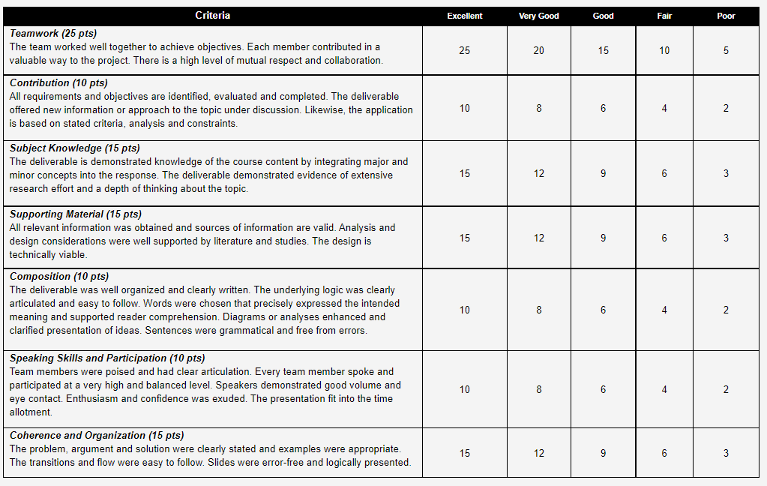**Grading Rubrics:**

GAME: MAPUA TYPING MANIA

TRACKER

|  |  |
| --- | --- |
| MAIN TASK | CHECKMARK |
| ALGORITHMN |  |
| PSEUDOCODE |  |
| FLOWCHART |  |
| GAME |  |

|  |  |  |  |
| --- | --- | --- | --- |
| SUBTASK | | | |
| MAIN CAMPAIGN | | EXTRAS | |
| TASK | CHECKMARK | TASK | CHECKMARK |
| STORY |  | LEADERBOARD |  |
| STAGE/ CAMPAIGN INTRO |  | MULTIPLAYER |  |
| STAGE 1 |  | GAMEMODE - ENDLESS |  |
| STAGE 2 |  | GAMEMODE - TIMED |  |
| STAGE 3 |  |  |  |
| STAGE ENDING |  |  |  |

Diri nato ibutang ang details sa baba:

Algorithmn:

Pseudocode:

FLOWCHART:

ASSIGNMENT:

WEEK 2:

STORY AND CONCEPTS

BOSS AND STAGES

WEEK 3:

RUSH CODE

WEEK 4:

POLISH